Title: Sand - The Thin Interface Between the Solid Earth and the Atmosphere

Suggested Grade Level – Middle School – High School

Time Required: A minimum of five class periods.

Materials and Technology Needed:

Materials:
Enough local or assorted samples of sand so that each group could have ≈ 250 ml
One balance capable of measuring a larger mass ≈ 1,000 g per group
10 X Magnifiers (one per group)
Low Power Binocular Microscope (optional)
Mineral Identification Kit (one per group)
Shape Identification Chart (one per group)
Magnet (one per group)
Dilute Hydrochloric Acid (one container for entire lab)
Safety Goggles (one per student)
Sieve Kit (minimum of one, preferably one per group)
Digital Camera (optional)
Digital microscope with camera (optional)

Technology:
Computers with access to the Internet
Image Processing program such as GIMP (optional)

Safety Considerations:

Goggles must be worn when doing acid testing on the grains

Teacher Preparation:

If possible the teacher should try to collect as many different sand samples as possible. This can be done with only one type of sand, but the investigation is much more exciting and inquiry based if there is a collection such as “Atlantic Coast Sand,” or “Pacific Coast Sand,” or “Gulf Coast Sand,” or “Beach Sand and Desert Sand.”

The teacher should be familiar with doing measurements in the image processing software.

The teacher should be familiar with, and be able to identify the basic minerals found in the local sand.

The teacher should be able to transfer images from a digital camera and/or digital microscope to whatever medium they are going to use to show the images.

Objectives and Learning Outcomes:

Basic Objectives:

Given ≈250 ml of sand a student should be able to complete the following tasks:

- Looking at the sand and comparing it to a sorting chart, a student should be able to make an observation on the degree of sorting of the entire sample and identify it as well, moderately, or poorly sorted based on the general size distribution of the grains. If the sand grains are mostly one size it is well sorted. If there is some mixture the sand is moderately sorted, if there are many different size grains in the sample it is poorly sorted.

- A student should be able to pour the sand sample through a sieve kit and find the mass of each size component.

- Given the mass of each different size of sand found with the sieve, a student should be able to calculate the percentage of each of those sizes.

- Given a mineral identification kit, 10X magnifier, magnet, and container of hydrochloric acid, a student should be able to identify the minerals in the sample.

- Given a random collection of 50 to 100 grains, a student should be able to count and find the percentage of each mineral in the random sample.

- Given a 10X magnifier and a shape identification chart, a student should be able to examine individual grains and determine their degree of roundness and coarseness.

- Given a map showing the geologic features of the area where the sand was collected, a student should be able to create a hypothesis on the origin of the sand.

Advanced Objectives (with multiple samples):

- Shown a map of the area where the samples were collected, a student should be able to form a hypothesis on how the sand will change as you go in a specific direction, and give a logical reason for their answer.

- Given a digital camera, a student should be able to take a macro image of the sample and post the image to a website. (optional)

- Given a digital microscope with camera, a student should be able to take a magnified image of the sand sample and post the image to a website. (optional)

- Given the results of their group’s investigation, a student should be able to post the results to a spreadsheet or website table.

- Given the completed table of data and images a student should be able to evaluate their hypothesis and see if they were correct.

Procedure:

Basic Lesson Using Sand from One Location

Before the lab begins you must gather enough sand for all of your groups. About 250 ml works best. I went to the local dollar store and bought screw cap containers @ two for $1.00 to hold the sand and store it for future years. You could also use one large container and have each group come up and take a sample in a 250 ml beaker.

Warning: The sand should be cleaned before the students handle it. This is best done by placing it into a bath of isopropyl alcohol, and allowing the alcohol to evaporate.

Pass out the instruction sheets for the lab. The important point to stress is that everyone will not get a chance to do everything. The group must decide who will complete the individual tasks, and they should all be done at the same time. People working in groups tend to stand around and watch as one task is accomplished, then move on to the next. Tasks for this lab include the following:

- One person should write a general description of the sand sample. As a minimum, that person should give the overall color or shade of the sand, and if the sand is well or poorly sorted. The person should also note any unique characteristics that they see.

- One or two people should count out 50-100 grains of the sample randomly, and do a count of how many different minerals they see, and the percentage of each mineral. They should also be given a mineral identification kit, hand lens, and magnet to aid in the identification of the minerals. I usually come around with a single container of hydrochloric acid so that students can test the grains to see if they react.

- After the general description has been written, one or two people should take the sample and calculate the different percentages of grain sizes by passing the sample through a sieve kit. The easiest way to do this is to find the mass of each of the individual empty sieves first. Then when the sample is poured into the kit they can simply subtract the mass of that section of the kit from the total mass of the sample and sieve section to get the mass of the sample. After all sections have been calculated they can find the total mass and calculate the percentage of each grain size.

As each group finishes, they should enter their data into a spreadsheet.

The following day, the spreadsheet should be shared with the class, and decisions made on how to handle the results by solving the following problems:

- Was there general agreement on the sorting of the sample?

- Was there general agreement on the general description of the sample? Did some groups see different characteristics from other groups? How do you handle that?

- Did everyone see the same minerals, and were their percentages the same? If not, how do you handle that?

- Did everyone get the same percentages for grain size? If not, how do you handle that?

Finally, a single set of data, and a single essay should be created to describe the analysis of the sand sample.

Variations on using sand from a single location with five classes:

Every class uses the same sample. This would be the easiest to do. At the end they could compare their answers for the final description and see how closely they matched.

Each class has its own unique location. Let’s say you collected the sample from a beach. One sample could come from close to the water, and the other samples could be taken from a progressively higher spot on the beach. Then comparisons could be made to see how the sand changed from location to location on the beach. You could give them the samples and not tell them from where on the beach the sample originated, and have them try and determine the sequence based on the data.

Advanced Lesson Using Sand from Many Locations

This is probably the most exciting way to do this activity. Collect as many different samples of sand as you can from a large area. In the United States you could attempt to do Atlantic Coastline, Gulf Coastline, Pacific Coastline, or any combination of the three. Students go on vacations. Make it a standard extra credit assignment that they must bring back a sample of sand that would fill a coffee mug. Have them take pictures of the area showing the surroundings, and write an essay describing the area. As the years go on, your collection will grow, and the lab will become more involved.

The procedure is identical with the Basic Lesson with the following alterations:

Each group gets a unique sample of sand. The only form of identification they get is an identification number written on the container.

The distribution of samples is going to determine the lab question. If you are fortunate to have a selection from an entire coastline, the Atlantic for example, you can have them hypothesize how the sand will change as they go from farthest point north to farthest point south. If you have samples from two different coasts, you could have them hypothesize what the difference will be between Atlantic and Pacific, or Atlantic and Caribbean, etc. The choices are endless. Whatever your options, show them a detailed map of the area(s). Dr. Ray Sterner from Johns Hopkins University has an incredible set of maps that I have used for various projects (Figure1).

Figure 1 Ray Sterner's Topographic Map of the United States

They should be able to see structures such as mountains, what the coastlines do, etc. to help them formulate their answers. Before the lab begins, have the students discuss their various hypotheses with each other. The students come up with fantastic ideas on what will happen as you go from coast to coast or north to south along the same coast.

When they enter the data into the spreadsheet it must be in a logical order. If you are comparing north to south, the answers should be entered by latitude. When they go to enter the data, the number of the sample should already be there, and they enter in that row. Some arrangement should be made to separate different coastlines.

If you have the ability to do this, and interesting alternative to the spreadsheet is to enter the data into a website table. When I did that, I had the students take two digital images of the sample. One was using the “macro” setting on the camera to get as close as possible to it. The second image was taken through an inexpensive digital microscope. Students took the two images, and then I transferred them to the website. I also linked the data to actual images of the site taken from the Internet. Last year’s results can be seen at http://www.gatesscience.info/teamescience//project/sand/sandata.htm

Given the finished product, either in spreadsheet or webpage form, students must evaluate their hypothesis and make a final judgment.

LAB SHEETS

ATLANTIC COAST BEACH SAND LAB
OBJECTIVE – How do the physical characteristics of Atlantic Coast beach sand change as you go from extreme northern latitudes toward the south?
HYPOTHESIS –
INDEPENDENT VARIABLE –
DEPENDENT VARIABLE –
MATERIALS –
Assorted Sand Samples | Forceps | Hydrochloric Acid (Dilute)
Balance | Magnet | Binocular Microscope
Sieve Kit | Ruler | Mineral Identification Sheet
Safety Goggles |  | Digital Microscope
Hand lens |  | Digital Camera

SAND ANGULARITY CHART
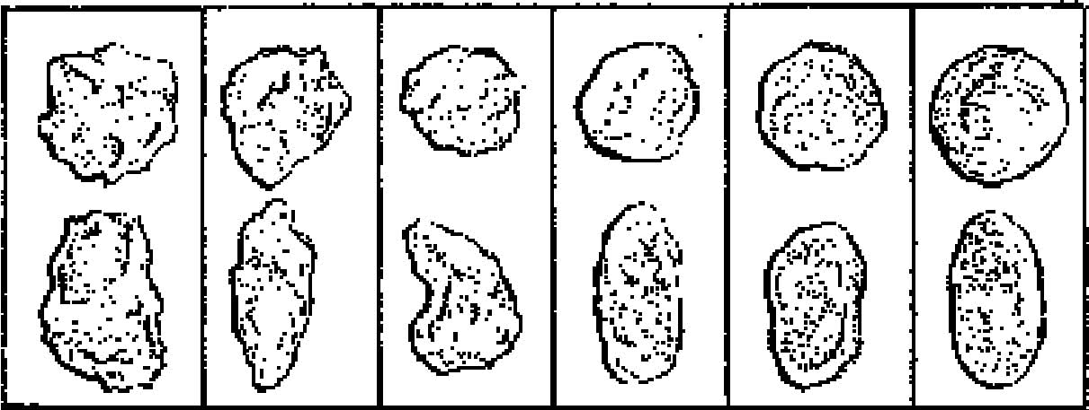
Very Angular Subangular Subrounded Rounded Very Rounded

SORTING CHART

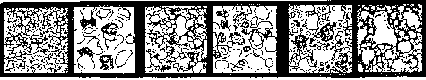
Well Sorted Moderately Sorted Poorly Sorted

PROCEDURE –
- Select a sand sample and record its number on your data sheet.
- Write a description of the entire sample. As a minimum describe the color and/or shading of the sample, and the sorting of the sample. If all of the grains are about the same size the sample is “well sorted.” If there are a great variety of grain sizes, the sample is “poorly sorted.”
- Find the mass of each section of the sieve kit, and record the mass.
- Pour the sand into the sieve, and separate it according to grain size.
- Find the mass of each section of the sieve kit with the sand added.
- Calculate the mass of each grain size.
- Calculate the mass of the entire sample by finding the sum of the masses of all of the different grain sizes.
- Determine the percentage of each sieve sample using the following
equation:
Mass of specific grain size / mass of the entire sample X 100 = %
- Describe each sample as to its angularity by comparing it to the
Angularity Chart.
- Take a photograph of a gross sample of sand using the digital camera.
11. Take a photograph of each grain size distribution using the digital
microscope.
12. Attempt to identify each of the different grains by looking at them under the 10X magnifier and comparing them to the mineral samples. Feel free to use the magnet on dark samples you suspect might be iron based. Drop a single grain of material that you suspect is organic into the dilute HCl to see if there is a positive reaction. Goggles must be worn when using HCl.
13. Collect 100 random grains of sand. Sort them, and calculate the percentage of each type of grain.
14. Enter your results into the spreadsheet.

NAMES ________________________________________________________________ Sand Sample _________
Mass of entire sample = __________________________grams

Sieve # (Grain Size) | Mass of Empty Sieve (grams) | Mass of Sample Size Plus Sieve (grams) | Mass of Sample Size (grams) | % of Sample that is that Size

Sample Identification
Grain Identification | Color | Transparency | Angularity | % | Comment

NAME _____________________________
ATLANTIC COAST SAND LAB

- What was your sample number? ____________

- What was the name of the beach, city and state where it was collected?

- Sand is created by rocks being abraded. Where did the rocks originate that formed the sand on your beach? Don’t skip over this question. Go back and look at the map. Do a little research.

- Some people thought that the size of the sand grain was controlled by the latitude. As you head from north to south, is there any pattern to the size of the sand grains? What is the pattern?

- Some people thought that the color of the sand was controlled by latitude. Their hypothesis was that because the concentration of the light was strongest in the southern latitudes, the sand would be bleached. Do the sands get lighter as you go south? If yes, do you think that’s controlled by the sun? If no, what does control the color of the sand?

- How does the percentage of each of the materials listed in the table below change, as you head from north to south? The three possible answers are increases, decreases, mixed.

Material | Change in %
Biotite
Muscovite
Hematite
Hornblende
Feldspar
Quartz
Garnet
Organics

7. Rewrite your hypothesis to explain what happens to the physical characteristics of sand as you head south. How confident are you in your answer? What would you need to do to prove it?

Results/Analysis:

Needless to say “results will vary!” In the basic lab it would be hoped that all of the groups came up with very similar answers for the percentages of the sand in each of the sieves, and were able to identify the minerals in the sand and calculate their percentages. If something went horribly wrong with the results, it would be an excellent lesson in how to handle data when something might be incorrect.

The more exciting lab is the Atlantic Coast Lab. The fascinating part is the discussion before the lab is started. Listening to all of the different hypotheses that the students have be they middle school or high school students is a lesson in student misinformation. I’ve done this lab two times now – once with middle school students and once with high school juniors and seniors. The most interesting misconception they have is the reason for the change in color of the sand. Many believe that the sand is lighter in the south because the sun has bleached it.

Teacher Reflections:

I love this lab! I was first introduced to it at the NSTA National Convention in St. Louis three years ago. I think the teacher was a high school teacher from Virginia. He brought bags of sand from several states along the Atlantic Coast and had us do the analysis. I was hooked! I came back to Massachusetts and immediately fired off messages to several listserves I belong to asking for samples. I specifically asked for samples from only the Atlantic Coast, but they came from everywhere! I’ve only done this with the Atlantic samples. The results are mixed. Both middle school and high school students find this very hard to do. They are fine with the mechanics of pouring the sand through the sieve, and calculating the percentages of the different sized particles. The problem comes with the identification of the minerals and calculation of the percentage of each mineral. The transition of going from a cm sized sample of the mineral down to trying to identify a grain-sized version of the mineral is difficult for just about everyone. I was surprised at that. They also did not enjoy the tedium of counting out 100 random grains (which I later amended to 50) to calculate the percentage of each mineral. Those results were almost useless in all three cases.

In our discussion after the lab, most students understood that as you head from north to south the minerals found in sand definitely do change. I ask them to try and create sand regions for the Atlantic Coast. Most still want to do it by color, and that isn’t bad. They realize that the South does have light colored sand, but they see it’s because of the composition rather than the sun bleaching the grains. Some actually can see the “big picture” of glacial deposits to the north, and the inland trending structure of the Appalachians having something to do with the structure of sand on the coast.

This lab changed my life, and I’m not joking about that. When I saw what that teacher in Virginia had done, I knew exactly where I wanted to go. I knew that the lab would have more meaning if the students could see images of the sand. As luck would have it, I went to another session at that convention where one of my friends was presenting a Toyota Tapestry Grant presentation on photographing snowflakes with an inexpensive digital microscope. I had my vehicle for doing it. The microscope was easy to use, and the students liked the results. In my personal life, I’ve gone beyond the digital microscope to use a very expensive macro lens to photograph sand samples.

Extensions:

I can’t do this briefly because it means so much to me. I want to create a database of sand samples for other schools to use. Over the years, actually since I was a kid, I’ve collected sand. Up until now I really haven’t done anything with it other than collect it in little vials with labels. In the first year of my retirement I’ve decided to concentrate on a state a week. As a result of me posting requests to several different lists, I’ve started to receive samples on a fairly regular basis. Their sample triggers the samples that I’m going to photograph from my collection along with the ones sent me, and post them to the Internet. Each page will contain a minimum of four pieces of data:

- a “zero magnification” image of the sand showing what it would look like to a person holding it in their hand

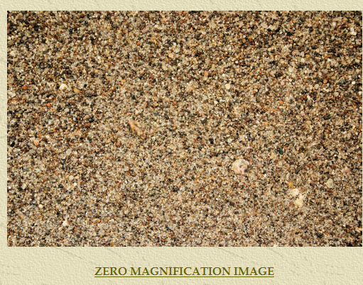

- a “3X” image of the sand that is roughly a 9 power image of the sand taken with the macro lens (the red line is something new. If you actually look at some of the other pages, the scale might be under the picture. I think the scale incorporated right into the image is more useful. If people actually wanted to measure the size of the individual grains using image processing software such as GIMP, they would have a digital reference.)

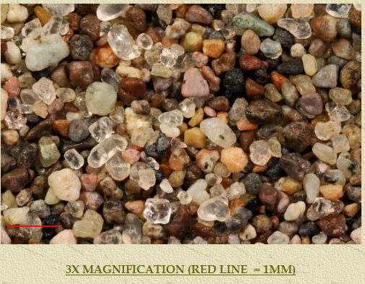

- an astronaut image of the location taken from either the International Space Station or the Space Shuttle. By clicking on the link you can go back to the “Gateway to Astronaut Photography” data page for the image, and discover all kinds of wonderful things about the image.

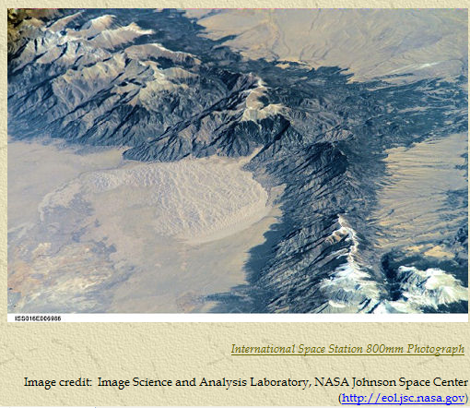

- a link to either images, geology, or the natural history of the location. I’ve also requested that people send me their own images of the area, as well as an essay of their choosing describing the area. So far that has been a dud with one brilliant exception (see below)!

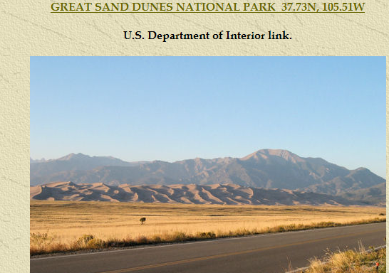

"So IT was: pick any or all of the following adjectives: awesome, spectacular, stunning, beautiful, spiritual. I could go on and on and think of more. But it was one of those experiences that will stay with me forever. And hopefully I'll have equally great pictures to look at over and over.
It was also surreal being there as the sun set just to the left of the imposing San Juan Mountains while the moon and Jupiter [it did appear all of a sudden about 10 minutes after we talked] shone brightly over the Sangre de Cristo Mountains behind me.
It was windy and chilly and I had the whole place pretty much to myself. How incredible was that? I passed people coming off the sand as I was heading out but there was no one else I could see ahead of me. There were people higher up on the dunes, I gather, since I could see flashlights shining. Or maybe the lights didn't belong to humans? It's that kind of place as it gets dark.
I walked about 1/4 to 1/3 of a mile toward the closest of the real high sand dunes. I kept taking pictures of the sunset, of the footprints all over the sand, of spaces of small ripples of sand totally surrounded by footprints but not a single one in the middle.
And then I turned around and realized if I didn't head back soon, I'd be out there with no idea where the path to the parking lot was! And I could see creatures scurrying around on the sand! What were they? I have no idea. And I decided I better get back. And besides, where was my flashlight but in the glove compartment!
It wasn't easy walking on the sand for me. Anything other than hard sand is not very good for my back. But this experience was worth any pain. And then it seemed darker all of a sudden. And I had to peer down and follow what I thought were the footprints.
Quite an experience! My oh my it was one of those true National Park experiences! And when you guys get out here, there's an incredible motel/lodge just outside the entrance to the park that has awesomely perfect views of the dunes! I immediately thought of Goulding's and you when I saw it. Another visit here and that would be the place to stay.
And one more thing, on the way out on the access road there was only one car in front of me that I eventually passed and only four going into the park. Speed limit 65 on an almost perfectly straight line once out of the park to the main highway. Well some small creature darted out in front of the car and never made it to the other side. And I think all the pieces have worn off my tires by now." - G. Bertrand

In addition there is a second page for that state or country showing all of the samples in one spot. There is a map of the state or country, and the samples are displayed as thumbnails in what looks like a stratigraphic column. This looks really cool!

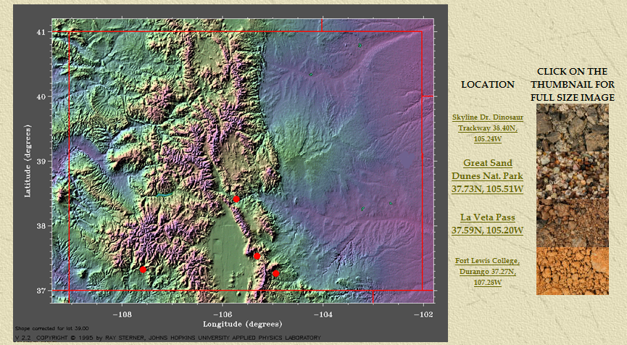

If you click on the thumbnail, a greatly exaggerated view of the 3X image is displayed.

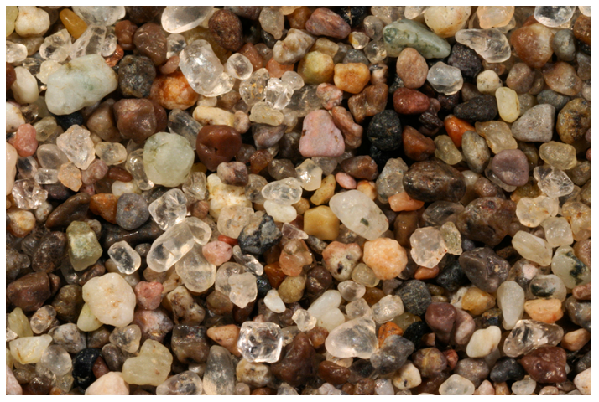

It is my hope that over this first year I will have samples from all 50 states and as many countries as I can get. The second year will be used to “fill in the blanks” and add samples to all of the locations. Response to this has been great so far. As each state “arrives,” I darken the map.

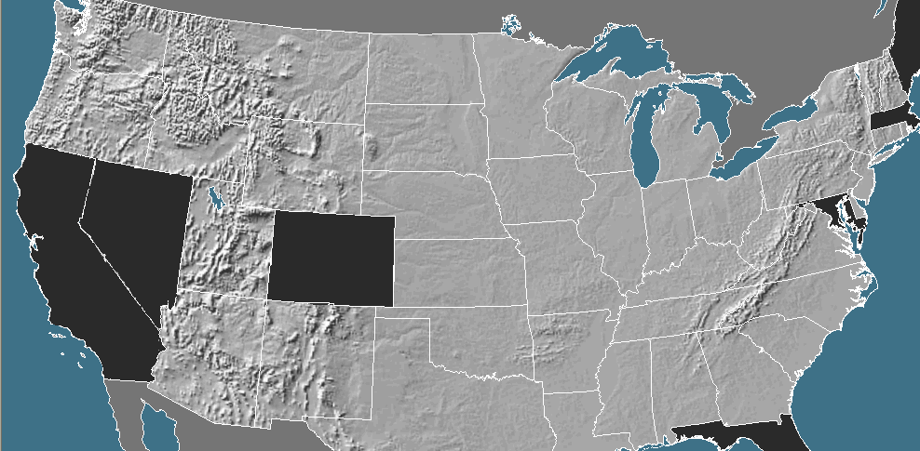

After the first year there should be a complete set of sand samples for all 50 states displayed to the same scale for educators to use as they want.

I really have no idea where this will lead. It will keep me busy for two years! I have met some very interesting people over the nine weeks since I’ve been doing this. Hopefully that will continue. What would really be neat is if people sent me a sample of sand to add to the data base, and also sent the results from their lab to include with the page.

Assessment Suggestions:

The most basic assessment would be the lab report grade. Was their analysis of the sample correct? Did they enter the information into the spreadsheet/website? I would especially look at their conclusion to see if it agreed with their hypothesis.

Standards Addressed:

Massachusetts Earth and Space Science Standards Grades 6-8

Standard 6 - “Describe and give examples of ways in which the earth’s surface is built up and torn down by natural processes, including deposition of sediments, rock formation, erosion, and weathering.”

Massachusetts Earth and Space Science Standards – High School

Standard 3 – Earth Processes and Cycles

3.1 – “Explain how physical and chemical weathering leads to erosion and the formation of soils and sediments, and creates various types of landscapes. Give examples that show the effects of physical and chemical weathering on the environment.”

References/Resources:

http://www.gatesscience.info/teamescience/project/sand/sandlab.htm - This is a link to my last Atlantic Coast Sand Lab. I did this with High School Juniors and Seniors in my Coastal Geology class.

http://www.gatesscience.info/teamescience/sand/sandintro.htm - This is the homepage for my current sand project “Bill and Charlie,” where I’m attempting to collect at least one sand sample from every state in the United States in one year.

http://www.sandcollectors.org/The_Hobby_of_x.html - This is a link to the International Sand Collectors Association. I haven’t had guts enough to send these people my $12.00 yet and join their association. I probably should. Their website is excellent, but some of it, including their membership application is almost impossible to read because of their choice of text color.

http://fermi.jhuapl.edu/states/states.html - This is the link to Dr. Ray Sterner from Johns Hopkins University’s Color Landform Atlas of the United States. He has created a topographic atlas by color for each of the states. It greatly resembles the MOLA map made of the topography of Mars many years ago by Mars Observer.

http://gallery.cs.umb.edu/gallery/main.php?g2_itemId=416153&g2_page=1 - I’m in communication with another retired science teacher who does a variation on what I do. When he taught, he had his students along with students and other faculty members in the building bring in sand samples which he posted to this site. The collection is quite impressive! He lives about 50 miles from me. He uses exactly the same lens to photograph the samples as well as the same storage tubes. Go figure!

Collier, Michael. Over the Coasts - an Aerial View of Geology. 1st. New York, New York: Miyaka Press, 2009. Print. – I was introduced to Michael Collier’s books when I started working for the Johnson Space Center’s “Exploring Earth and Beyond Project.” When I flew back to Massachusetts from Houston it was a glorious clear day the entire way. We had just been engrossed in a week long session on how NASA gathers images of the Earth from the International Space Station and how they process the images. Our task was to design lessons to spark interest in students to design proposals for using astronaut photography to interpret changes in structures in the landscape. All I wanted to do was to take pictures the entire way, and the ones I took were terrible. Then I saw Collier’s book Over the River for $2.00 at Amazon and bought it. It was exactly what I needed. That was closely followed by Over the Mountains. They are things of beauty and guaranteed to start discussions. These are semi coffee table books that are fairly expensive, but you can get them from a distributor such as Amazon for a few dollars. The images are stunning. In Over the Coasts he does each of the major sections of the United States, much as I would like to do in my lab, and presents incredible images of the structures of the beaches.

Greenberg, Gary. A Grain of Sand - Nature's Secret Wonder. 1st. Minneapolis, MN: Voyageur Press, 2008. Print. – A thing of beauty! It’s a picture book, and I want to make one just like it.
Komar, Paul. Beach Processes and Sedimentation. 1st. Englewood Cliffs, NJ: Prentice-Hall, 1976. Print. – This was my text for Oceanography in Grad school. It covers geomorphology of beaches more than sand, but it also gives coverage of Pacific beaches missing in the Neal text.

Neal, William, Orrin Pilkey, and Joseph Kelley. Atlantic Coast Beaches. 1st. Missoula, Montana: Mountain Press, 2007. Print. – This is a great book. I used it in my middle school earth science course, and also in my coastal geology course. The discussion is obviously limited to the Atlantic Coast, but it gave me all of the background I needed for this lab.

Siever, Raymond. Sand. 1st. New York, New York: W. H. Freeman , 1988. Print. – This is a volume in the “Scientific American Library” series. Siever supposedly wrote this book for the general public, but I bet it was never a big seller. There is more than anyone would ever want to know about feldspar in this volume. It does a great job in describing how the different types of sand are created.

Welland, Michael. Sand the Never-Ending Story. 1st. Los Angeles, CA: University of California Berkley, 2009. Print. – This supposedly is the be all and end all text on sand for the general reader. I just got this a few weeks ago and haven’t had a chance to read it yet. Two of my friends told me about it. One of my relatives actually bought it for me after she heard a review on NPR and was shocked that I already had it. She decided to keep a copy for herself. Giving it a quick scan, I would say that it probably does what Siever’s book was supposed to do.

