ATLANTIC COAST BEACH SAND LAB
OBJECTIVE – How do the physical characteristics of Atlantic Coast beach sand change as you go from extreme northern latitudes toward the south?
HYPOTHESIS –
INDEPENDENT VARIABLE –
DEPENDENT VARIABLE –
MATERIALS –
Assorted Sand Samples | Forceps | Hydrochloric Acid (Dilute)
Balance | Magnet | Binocular Microscope
Sieve Kit | Ruler | Mineral Identification Sheet
Safety Goggles |  | Digital Microscope
Hand lens |  | Digital Camera

SAND ANGULARITY CHART
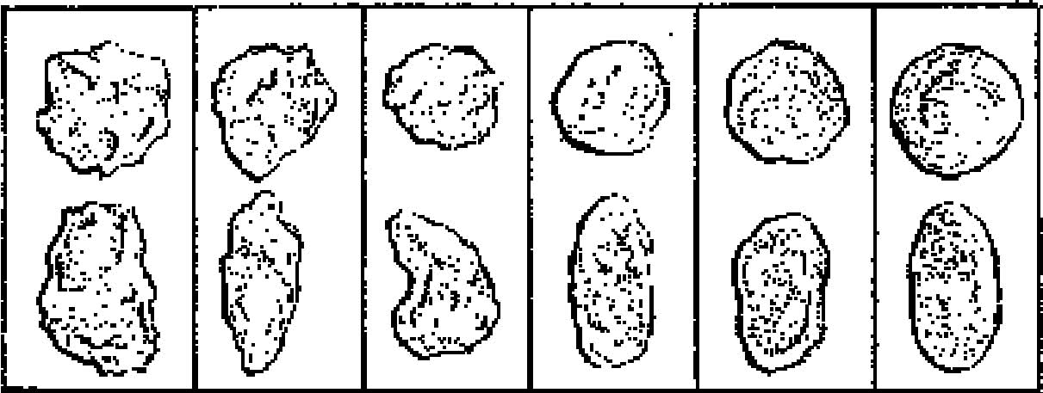
Very Angular Subangular Subrounded Rounded Very Angular Rounded

PROCEDURE –
- Select a sand sample and record its number on your data sheet.
- Find the mass of the entire sample and record it.
- Find the mass of each section of the sieve kit, and record the mass.
- Pour the sand into the sieve, and separate it according to grain size.
- Find the mass of each section of the sieve kit with the sand added.
- Calculate the mass of each grain size.
- Determine the percentage of each sieve sample using the following
equation:
Mass of specific grain size / mass of the entire sample X 100 = %
- Describe each sample as to its angularity by comparing it to the
Angularity Chart.
- Take a photograph of a gross sample of sand using the digital camera.
10. Take a photograph of each grain size distribution using the digital
microscope.
11. Attempt to identify each of the different grains by looking at them under the binocular microscope and comparing them to the mineral samples. Feel free to use the magnet on dark samples you suspect might be iron based. Drop a single grain of material that you suspect is organic into the dilute HCl to see if there is a positive reaction. Goggles must be worn when using HCl.
12. Collect 100 random grains of sand. Sort them, and calculate the percentage of each type of grain.
13. Enter your results into the spreadsheet.

